**1-08-24 Java Lab Codes**

Program 1:

import java.util.StringTokenizer;

class Simple{

    public static void main(String[] args)

    {

        StringTokenizer st = new StringTokenizer("my name is khan"," ");

        while(st.hasMoreTokens())

        {

            System.out.println(st.nextToken());

        }

    }

}

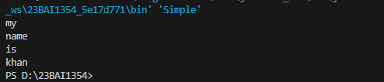

Program 2:

import java.util.StringTokenizer;

class Simple{

    public static void main(String[] args)

    {

        StringTokenizer st = new StringTokenizer("my,name,is,khan");

        System.out.println("Next Token is: "+st.nextToken(","));

    }

}

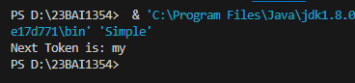

Program 3:

import java.util.StringTokenizer;

class Srr{

    public static void main(String[] args)

    {

        StringTokenizer st = new StringTokenizer("Demonstrating methods from String Tokenizer class in Java Lab class held on Thursday at VIT Chennai during the afternoon"," ");

        while(st.hasMoreTokens())

        {

            System.out.println(st.nextToken());

        }

    }

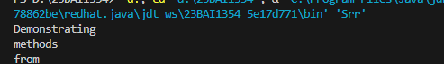}

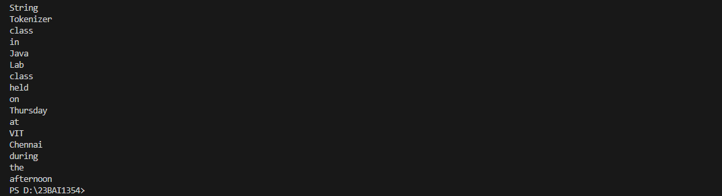

Program 4:

import java.util.StringTokenizer;

class Srr{

    public static void main(String[] args)

    {

        StringTokenizer st = new StringTokenizer("Hello everyone I am  Java developer"," ");

        while (st.hasMoreElements())

        {

            System.out.println(st.nextToken());

        }

    }

}

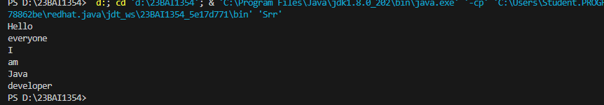

Program 5:

import java.util.StringTokenizer;

class Srr{

    public static void main(String[] args)

    {

        StringTokenizer st = new StringTokenizer("Hello everyone have a nice day","");

        while (st.hasMoreElements())

        {

            System.out.println(st.nextElement());

        }

    }

}



Program 6:

import java.util.StringTokenizer;

class Srr{

    public static void main(String[] args)

    {

        StringTokenizer st = new StringTokenizer("Hello everyone have a nice day"," ");

        System.out.println("Total number of Tokens: "+st.countTokens());

    }

}



**ARRAYS**

Program 7:

public class Array

{

    public static void main(String[] args)

    {

        int[] arr;

        arr = new int[5];

        arr[0]=10;

        arr[1]=20;

        arr[2]=30;

        arr[3]=40;

        arr[4]=50;

        for(int i=0;i<arr.length;i++)

        {

            System.out.println("Element at index "+i+": "+arr[i]);

        }

    }

}

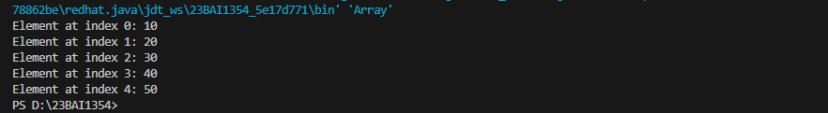

Program 8:

class Student{ //Parameterized Contructor calling

    public int roll_no;

    public String name;

    Student(int roll_no, String name) //constructor

    {

        this.roll_no=roll_no;

        this.name=name;

    }

}

public class Array

{

    public static void main(String[] args)

    {

        Student[] arr;

        arr=new Student[5];

        arr[0]= new Student(1,"aman");

        arr[1]= new Student(2,"george");

        arr[2]= new Student(3,"pman");

        arr[3]=new Student(4,"mad");

        arr[4]=new Student(5,"yeda");

        for(int i=0;i<arr.length;i++)

        {

            System.out.println("Index: "+i+" Roll no: "+arr[i].roll_no+" Name: "+arr[i].name);

        }

    }

}

